 | 
Palestinian Central Bureau of Statistics (PCBS) | Arab American University  (AAUP)
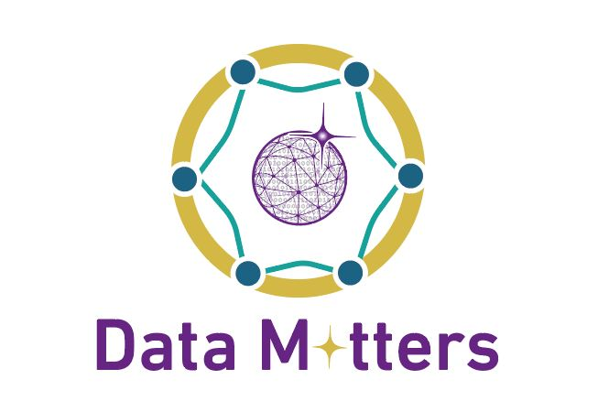
Data Matters Festival
Concluding Statement
Ramallah - October 20th, 2019

Realizing that the Data Science Festival is being held in celebration of the World Statistics Day on October 20th, and given the role of the government and all sectors in promoting and providing the required support for creative initiatives, including the Data Science Initiative, to improve decision-making at all levels, and

Recognizing the importance of partnerships and exchange of experiences in the use of data science and the extent of its contribution to serve humanity and the measurement of Sustainable Development Goals, and

In alignment with the National Policy Agenda and directions of the Palestinian Government, that accords great priority to youth and entrepreneurship,

We, the participants of the first Data Science Festival in Palestine representing ministries, academic institutions, and research centers, representatives of civil society organizations, the private sector, and all attendees interested in the field of data science, welcome this initiative and this global event,

We affirm the importance of data in human life, including the provision of data on all aspects of life, and the need to make data available for public use, while ensuring data confidentiality and privacy of individuals, and

We highlight the role of the Data Science Initiative, including all of its projects, in helping to improve the status of Palestine by using the information revolution and big data to overcome challenges and achieve sustainable social development to serve public good, and
We call for a full partnership between all national institutions from the private and civil sectors, in addition to the components of the National Statistical System to provide the necessary support for the initiative’s success and growth, and

We stress the importance of creating special data science training programs for all segments of society. In particular, we recommend focusing on youth, so that they gain the skills they need to achieve their aspirations, and

We, the participants, call for:
- Considering data science as relevant to all business domains, and – therefore – people from all specializations should develop data science skills;
- Encouraging the government and the actors in the private and civil society sectors to adopt the Data Science Initiative in Palestine as a foundational and pioneering step to serve the society, especially youth;
- Strengthening the partnership opportunities, and so, invite all relevant institutions from different sectors to join the Data Science Initiative to promote different data sources, including administrative records;
- Establishing of the Palestinian Society for Data Science as the incubator for corresponding standards, best practices and professional ethics and encouraging Palestinian competencies in the homeland and the Diaspora to join this society;
- Promoting a culture of evidence-based decision-making by building on what data science can offer, in terms of knowledge and insights and overcome business constraints, using best methodologies;
- Embedding data science skills in the curricula of schools and universities in order to equip students with data intuition and motivation to engage in data science;
- Adopting capacity development programs in data science for employees and executives by different institutions, in all sectors, according to their business domains and needs;
- Linking this national initiative to international efforts in order to accumulate, update and build on global knowledge;
- Strengthening networking with Palestinian experts in data science in all their locations to furnish Palestinian youth in all sectors of society with international expertise in this field;
- Providing support to the Data Science Initiative by all sectors of society to implement its various core projects, including the following:

- Data Matters Festival.
- Think Data Science Program.
- Data Science for Executives & Leaders.
- Data Science for Schools: “Schools without Walls”.
- Data Science Society of Palestine.

