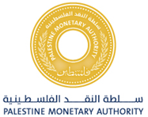
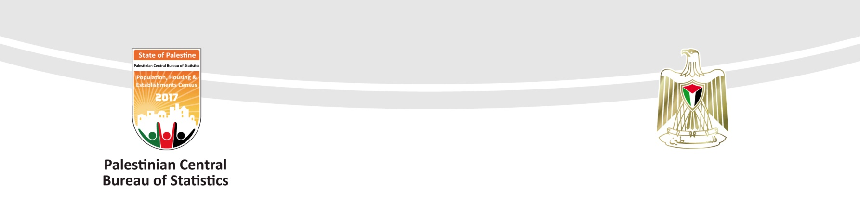

Central Bureau of Statistics (PCBS) and the Palestine Monetary Authority (PMA)

Results Announcement
International Investment Position & External Debt Second Quarter 2017

The Palestinian Central Bureau of Statistics (PCBS) and the Palestine Monetary Authority (PMA) announced the preliminary results of the International Investment Position (IIP), and External Debt statistics for Palestine as of end of second quarter 2017.

The primary results of the IIP (external assets – foreign liabilities) for Palestine at the end of second quarter 2017 revealed that the net IIP amounted to about USD 1,102 million, which means that the Palestinian economy’s investments outside Palestine outweighs investments in Palestine from abroad. The resident cash deposits in foreign banks and foreign exchange in the Palestinian economy accounted for the bulk of the external assets, constituting 63% of the total value of external assets.

The total stocks of External Assets for Palestine amounted to USD 6,204 million, the Foreign Direct Investment abroad contributed to 6.3%, Portfolio Investments abroad reached 19%, while Other Foreign Investments abroad (mainly currency and deposits) reached 67.3% and Reserve Assets amounted to 7.4%. At sectoral level, the external investments of banks sector represented a large share of the external assets, standing at 75.2% of the total value of external assets.

The total stocks of Foreign Liabilities in Palestine (Stocks of non-residents invested in Palestine) amounted to USD 5,102 million, the Foreign Direct Investment in Palestine contributed to 50%, Portfolio Investments in Palestine reached 13.8% and Other Investments in Palestine (mainly loans and deposits from abroad) amounted to 36.2%. According to sectoral level, the foreign investments in banks sector contributed a major value in the foreign liabilities, represented by 38.4% of the total value of foreign liabilities on Palestinian economy.

The Gross External Debt on different sectors of the Palestinian economy reached USD 1,854 million, the debt on government sector represented 55%, while debt on banks sector reached 40.9%, and debt on other sectors (Nonbank financial corporations, non-financial corporations, NGOs and household sector) amounted to 3.8%, and the lending between affiliated companies reached 0.3%.

The International Investment Position (IIP) is an accounting sheet that records the investments stocks for the residents in Palestine (individuals, institutions and government) invested in the rest of the world (abroad) under the name of (assets), and compares them to the investments stocks owned by residents outside Palestine (individuals, institutions and government) invested in Palestine under the name of (liabilities).

The Balance of Payments Manual - fifth edition, issued by the International Monetary Fund in 1993, divides the assets and liabilities into direct investment (investment by 10% and more in the non-resident capital), and portfolio investment (investment less than 10% in the non-resident capital as well as investment in bonds), and other investments. It divides these other investments into stocks of trade credit, loans, currency and deposits and any other assets or liabilities), in addition to the Reserve Assets, i.e. Stocks held by the Central Banks/ Monetary Authorities to address the imbalances in the balance of payments, it is worth mentioning that the reserve assets are only included in the asset side.

The External Debt is an accounting sheet that records the debt stocks on Palestinian economic sectors due to non-residents. These include (loans from non-residents, the deposits of the non-residents deposited in the banks sector in Palestine, the Palestinian bonds purchased by non-residents, debt transactions between the non-resident enterprises and fellow enterprises in Palestine. They encompass as well any other liabilities on Palestinian economy) the data of external debt have been extracted from the liabilities side in the international investment position matrix (debt items). Preparing, classifying and publishing of the data based on (External Debt Statistics Manual) issued by IMF in 2003, this manual is harmonized with 5th edition of Balance of Payments and International Investment Position Manual

For further details please contact:

Palestinian Central Bureau of Statistics | Or | Palestine Monetary Authority
P.O. Box 1647, Ramallah- Palestine. |  | P.O. Box 452, Ramallah- Palestine.
Tel: (972/970) 2 2982700 |  | Tel: (972/970) 2 2415250
Fax: (972/970) 2 2982710 |  | Fax: (972/970) 2 2409922
Toll free: 1800300300
E-Mail: diwan@pcbs.gov.ps |  | E-Mail: Info@pma.ps
Website: http://www.pcbs.gov.ps |  | Website: http://www. pma.ps
 |  | Issued on : 26/09/2017

Table 1: International Investment Position (IIP) stock by Economic Sectors For Palestine, at the end of the Second Quarter 2017

Value in million USD

TOTAL | Other Sectors |  | Banks Sector | Government Sector | Monetary Authorities (PMA) | Economic Sector  Investments Stocks by  Type of Investment
TOTAL | House- Holds Sector | Nonbank Financial Corporations, Non-Financial Corporations, and NGOs Sector
1,102 | -883 | -526 | 2,704 | -991 | 798 | International Investment Position (net)*
6,204 | 64 | 649 | 4,663 | 30 | 798 | Total External Assets
389 | 43 | 346 | 0 | 0 | 0 | Foreign Direct Investment Abroad
1,178 | 0 | 146 | 928 | 0 | 104 | Portfolio Investments Abroad
4,178 | 21 | 157 | 3,735 | 30 | 235 | Other Investments Abroad
3,911 | 21 | 0 | 3,655 | 0 | 235 | Of which: currency and deposits**
459 | 0 | 0 | 0 | 0 | 459 | Reserve Assets
5,102 | 947 | 1,175 | 1,959 | 1,021 | 0 | Total Foreign Liabilities
2,551 | 947 | 737 | 867 | 0 | 0 | Foreign Direct Investment in Palestine
702 | 0 | 368 | 334 | 0 | 0 | Foreign Portfolio Investments in Palestine
1,849 | 0 | 70 | 758 | 1,021 | 0 | Foreign Other Investments in Palestine
1,064 | 0 | 43 | 0 | 1,021 | 0 | Of which: Loans from abroad
758 | 0 | 0 | 758 | 0 | 0 | Of which: currency and deposits***

Notes:
- The data in the above table are close to the nearest integer.
- The data does not include the value of land owned by non-residents.
* International investment position (net): equals total external assets minus total foreign liabilities.
** Currency and deposits: Including residents deposits in banks abroad, in addition to foreign currency cash in Palestinian economy.
*** Currency and deposits: Include the deposits of non-residents deposited in resident banks.

Table 2: Gross External Debt position on Palestine, at the end of the
First and Second Quarters 2017

Value in million USD

Stock at the end of the Second Quarter 2017 | Stock at the end of the First Quarter 2017 | Economic Sector
1,021 | 1,055 | General Government
60 | 86 | Short-term
961 | 969 | Long-term
0 | 0 | Monetary Authorities
0 | 0 | Short-term
0 | 0 | Long-term
758 | 796 | Banks
393 | 475 | Short-term
365 | 321 | Long-term
70 | 63 | Other Sectors
3 | 3 | Short-term
67 | 60 | Long-term
5 | 3 | Direct Investment: lending between affiliated companies
0 | 0 | Debt liabilities to affiliated enterprises
5 | 3 | Debt liabilities to direct investors
1,854 | 1,917 | Gross External Debt Position

